FEATURED SPEAKERS:

REBECCA CROCHIERE
Clinical Psychology Doctoral Candidate
Department of Psychology
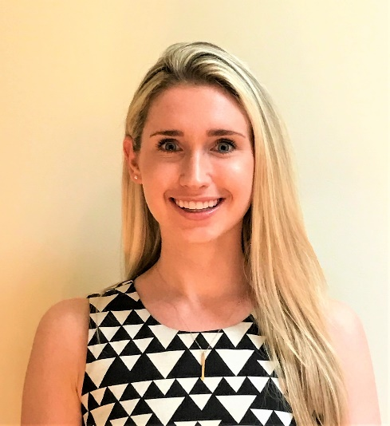
Title of the Talk: Sensors Versus Momentary Self-Report in Predicting Overeating Episodes
Bio: Rebecca Crochiere, MS, is a 4th-year clinical psychology doctoral student working under the mentorship of Evan Forman, Ph.D., in the Weight, Eating and Lifestyle Science (WELL) Center at Drexel University. Her research interests focus on using mobile health technology, specifically sensor technology, and advanced statistical techniques to model the relations between momentary risk factors and maladaptive eating behaviors. She hopes to use these predictive statistical models to inform the development of momentary interventions that target nonadherence to weight loss treatments.

HANNAH SPECE
Ph.D. Candidate in Biomedical Engineering
College of Engineering

Title of the Talk: You Can Print That?! Using 3D Printing as a Tool for Medical Devices and More

Bio: Hannah Spece is a 5th-year Ph.D. Candidate in the Biomedical Engineering program. She works under the guidance of Dr. Steven Kurtz at the Drexel Implant Research Core and is completing her thesis on the creation and characterization of 3D printed polyetheretherketone for orthopedic bone ingrowth applications. In 2019, Hannah studied in Munich and Frankford alongside 3D printing start-up Kumovis to learn about state-of-the-art printing systems and how they are being used by industries around the world. She has been a co-advisor to BME senior design teams and has taught a Drexel honors class related to 3D printing as an intersection between art and science. During the early months of the Covid-19 pandemic, she also assisted the Drexel Face Shield Project with printing and assembling PPE for local hospitals and organizations.

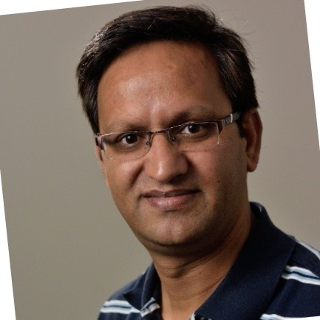
FACULTY MODERATOR:
RAJVEER SINGH, PHD, EIT
Research Scientist/Associate
Department of Civil, Architectural, and Environmental Engineering
Drexel University

